Dataset Description

The obtained data consists of 400 records with 24 features including both numerical and categorical variables. The “Type” column holds the different types of migraine diagnosed and it is the target variable in the study that need to be classified by the selected model.

SL.NO | ATTRIBUTES | DESCRIPTION | TYPE OF DATA | RANGE OF VALUE
1 | Age | Age Of the Patient Reported | Continuous | 15 To 77
2 | Duration | Length Of Symptoms During the Most Recent Episode, Measured in Days. | Discrete | 1 To 3
3 | Frequency | Monthly episode frequency | Discrete | 1 To 8
4 | Location | Either unilateral or bilateral pain location  (none - 0, unilateral - 1, bilateral - 2) | Discrete | 0 To 2
5 | Character | Character depicts the throbbing or persistent sensation of pain.  (none - 0, throbbing - 1,  Persistant - 2) | Discrete | 0 To 2
6 | Intensity | The level of pain, categorised as mild, moderate, or severe (none - 0, mild - 1, moderate -  2, severe - 3) | Discrete | 0 To 3
7 | Nausea | Patient's sensation of nausea (not - 0, yes - 1) | Discrete | 0 To 1
8 | Vomit | Patient's sensation of vomiting (not - 0, yes - 1) | Discrete | 0 To 1
9 | Phonophobia | Sensitivity to noise  (not - 0, yes - 1) | Discrete | 0 To 1
10 | Photophobia | Sensitivity to light  (not - 0, yes - 1) | Discrete | 0 To 1
11 | Visual | The count of reversible visual symptoms | Discrete | 0 To 4
12 | Sensory | The count of reversible sensory symptoms | Discrete | 0 To 2
13 | Dysphasia | Impaired speech coordination  (not - 0, yes - 1) | Discrete | 0 To 1
14 | Dysarthria | Disarticulated noises and words  (not - 0, yes - 1) | Discrete | 0 To 1
15 | Vertigo | Symptom of dizziness (not - 0, yes - 1) | Discrete | 0 To 1
16 | Tinnitus | Patient's ability to hear things (not - 0, yes - 1) | Discrete | 0 To 1
17 | Hypoacusis | Deafness (not - 0, yes - 1) | Discrete | 0 To 1
18 | Diplopia | Dual vision  (not - 0, yes- 1) | Discrete | 0 To 1
19 | Defect | Simultaneous frontal eye field and nasal field defect in both eyes (not - 0, yes - 1) | Discrete | 0 To 1
20 | Ataxia | Lack of muscular control (not - 0, yes - 1) | Discrete | 0 To 1
21 | Conscience | Compromised moral awareness (not - 0,  Yes - 1) | Discrete | 0 To 1
22 | Paresthesia | Bilateral paraesthesia at the same time (not - 0, yes - 1) | Discrete | 0 To 1
23 | DPF | Family history (not - 0, yes - 1) | Discrete | 0 To 1
24 | Type | Type Of Migraine Diagnosed  (Typical  Aura With Migraine, Migraine Without  Aura, Typical Aura Without Migraine,  Familial Hemiplegic Migraine,  Sporadic Hemiplegic Migraine,  Basilar-Type Aura, Other) | Nominal | Nill

INTERPRETABILITY ANALYSIS USING SHAP
To make model decisions clear and actionable for healthcare professionals interpretability analysis was performed for the effective algorithm identified (Random Forest and TabNet). The technique used to identify the interpretability of the model was SHapley Additive exPlanations (SHAP) summary and waterfall plots. SHAP is used to better understand the model's prediction for a particular input, the contribution of each feature to this prediction is calculated.
The feature that holds the most importance is the one that exhibits the most extensive range of SHAP values acquired for that feature. The relative contribution is determined in relation to the base value. Each dot represents the contribution of a specific feature, where blue denotes lower values and red suggests higher values in a SHAP plot.

Random Forest Model

The RF SHAP summary plot (Figure 1) provides an overview of the way in which
various features interact and contribute to the model's predictions throughout the dataset. It was noted that features such as Age, Intensity, and Vomit have substantial interactions with other features, such as Frequency and Duration, which underscores their significant impact on the model's predictions. In contrast, features such as Phonophobia and Photophobia exhibit minimal interaction with other features as they exhibit narrower spreads of SHAP values. This suggests that these features have fewer complex relations with other features in the dataset, resulting in more direct and isolated contributions to the model's predictions.
At the same time, the RF SHAP waterfall plot (Figure 2) provides a detailed explanation of how individual features contribute to the prediction for class 1 for the first instance in the test set. Starting from a baseline value of 0.143, reflective of the average probability for class 1 throughout the dataset, it illustrates how each feature either increases or decreases the predicted chance for this specific case. Phonophobia has the most significant positive impact, increasing the predicted probability by 0.11 units, pushing the prediction toward class 1.
Conversely, Duration and Photophobia have the largest negative impacts, decreasing the prediction by 0.07 and 0.06, respectively. Other features such as Intensity and Vomit contribute smaller positive and negative effects, respectively. The final prediction of 0.143 reflects the cumulative influence of these features on the model's decision, showing that while some features increase the probability, others tend to reduce the probability of this instance being classified as class 1.

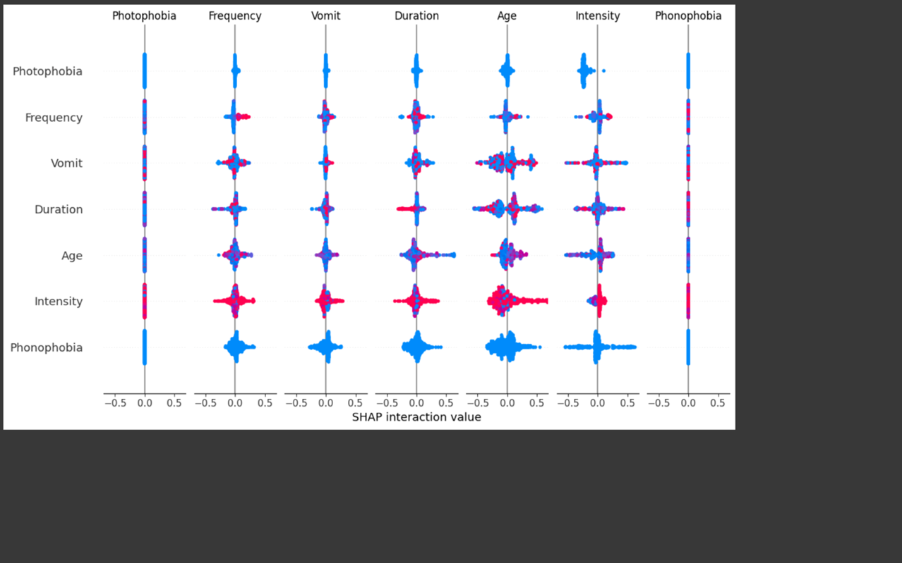
Figure 1: SHAP summary plot for RF model Interpretability Analysis.
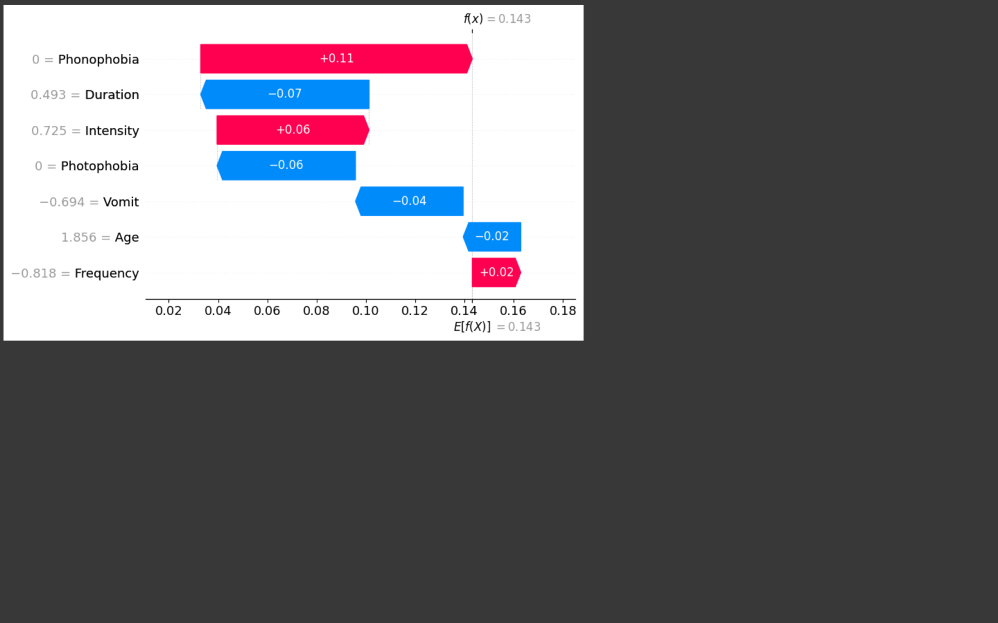
Figure 2: Waterfall plot Analysis of RF model.
TabNet Model

While observing the TabNet summary plot (Figure 3) the features such as Age, Intensity, Frequency, and Duration exhibit substantial interactions with other features, indicating that their importance varies across different instances. In contrast, features such as Phonophobia and Photophobia exhibit narrower spreads of SHAP values, indicating that they contribute in a more direct and isolated way to the model’s predictions. Additionally, the presence of a wider SHAP value distribution across multiple features strongly emphasis that TabNet personalises its decision-making by selecting different features for different instances, making it an adaptive model.
On the other hand, the waterfall plot (Figure 4) provides a detailed explanation of how individual features contribute to the classification decision for a specific instance in the test set. Age has the highest positive impact (+1.25), pushing the prediction toward a higher classification probability, while Intensity (-0.63) and DPF (-0.58) contribute the most significant negative impacts, reducing the probability. Notably, Dysarthria appears in this instance, even though it was not identified as a key feature in the summary plot. This suggests that TabNet dynamically includes features based on each instance or cases, making it more flexible in its decision-making. This instance-based feature selection strengthens the adaptability of TabNet allowing for more personalised predictions, but it also introduces challenges in model interpretability as the changing feature importance per case complicates clinical validation.

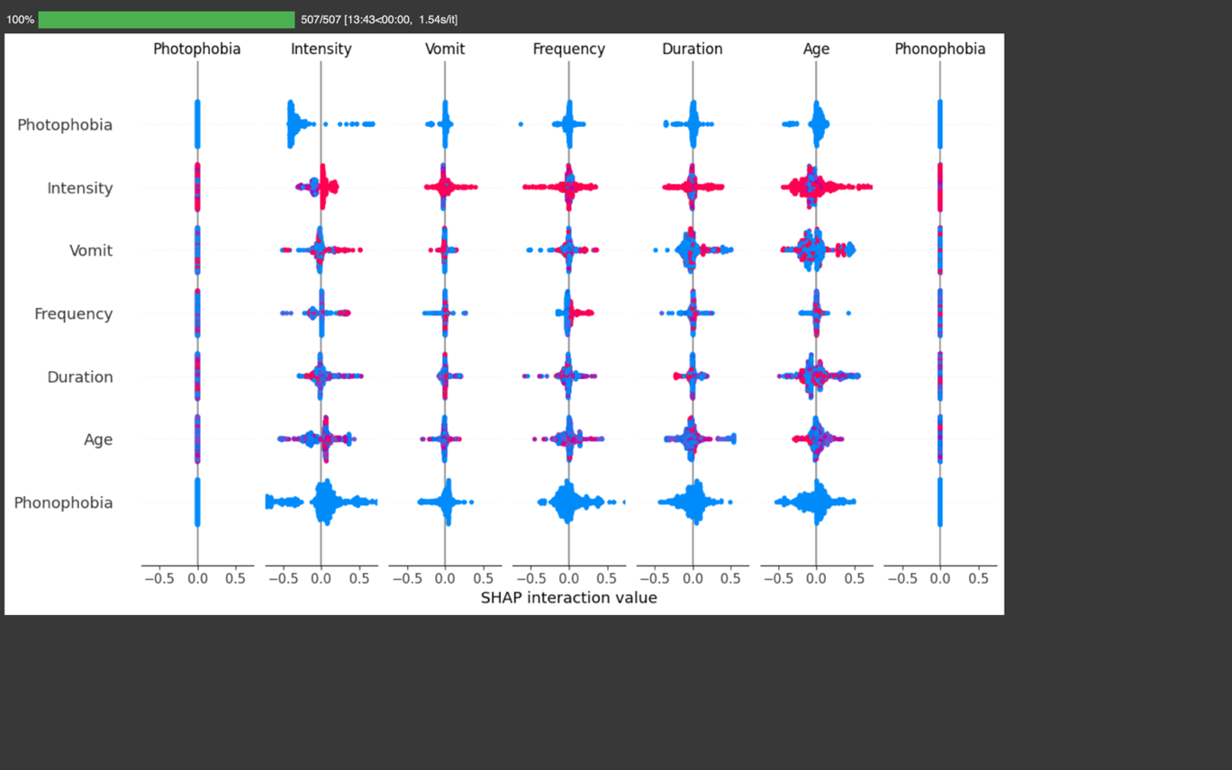

Figure 3: SHAP Summary Plot for TabNet Model Interpretability Analysis.

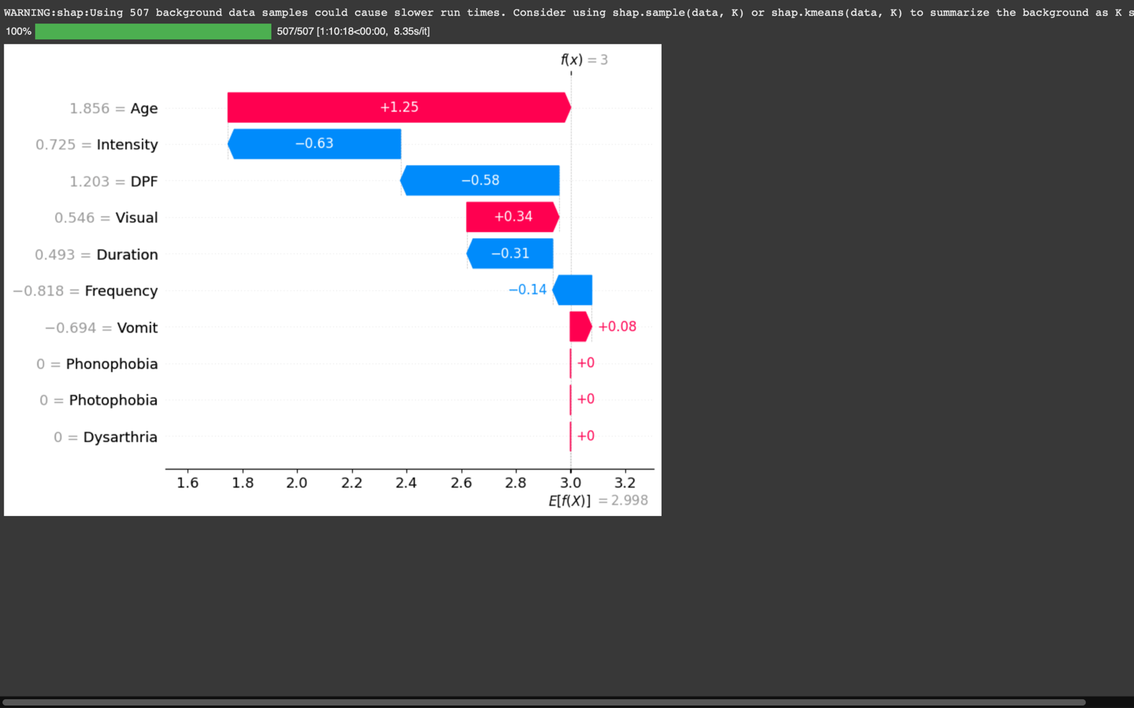

Figure 4: Waterfall Plot Analysis of TabNet Model.

